

# CS 305 Project Two

**Practices for Secure Software Report**

Table of Contents

Document Revision History 3

Client 3

Instructions 3

Developer 4

1. Algorithm Cipher 4

2. Certificate Generation 4

3. Deploy Cipher 4

4. Secure Communications 4

5. Secondary Testing 4

6. Functional Testing 5

7. Summary 5

## Document Revision History

| **Version** | **Date** | **Author** | **Comments** |
| --- | --- | --- | --- |
| **1.0** | **04/14/2022** | **Douglas New** |  |

## Client



## Instructions

Deliver this completed Practices for Secure Software Report documenting your process for writing secure communications and refactoring code that complies with software security testing protocols.

Respond to the steps outlined below and replace the bracketed text with your findings in your own words. If you choose to include images or supporting materials, be sure to insert them throughout.

## Developer

[insert name here]

## 1. Algorithm Cipher

Determine an appropriate encryption algorithm cipher to deploy given the security vulnerabilities, justifying your reasoning. Be sure to address the following:

* Provide a brief, high-level overview of the encryption algorithm cipher.
* Discuss the hash functions and bit levels of the cipher.
* Explain the use of random numbers, symmetric vs non-symmetric keys, and so on.
* Describe the history and current state of encryption algorithms.

Artemis Financial is requesting additional security for its web application to ensure secure communication. If we consider that the vector of the most likely attack to occur with the financial institution is a bad character, who is trying to gain financial gain by accessing stored information, encryption would be the best recommendation. This will make the files useless without the keys of any potential attacker. As the company seeks to protect communications, I would recommend Asymmetric communications. Which means the encryption key is public and the decryption key is private. To use the highest level of security as this information can be exported, I would suggest using the SHA-256 cipher algorithm with 256-bit keys to encrypt. The SHA-256 encryption offers the highest level of encryption with many different key combinations and 256-bit key lengths. Additionally, the SHA-256 algorithm uses a random Java number generator that ensures secure encryption by creating an unstable check that ensures file compatibility. The hash function will use the SHA-256 cipher to create a given message checksum.

## 2. Certificate Generation

Generate appropriate self-signed certificates using the Java Keytool, which is used through the command line.

* To demonstrate that the keys were effectively generated, export your certificates (CER file) and submit a screenshot of the CER file below.

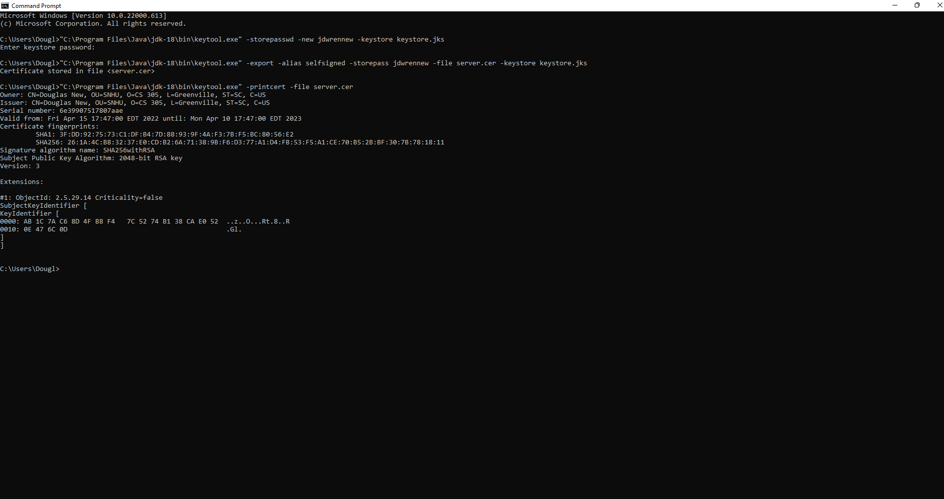

## 3. Deploy Cipher

Refactor the code and use security libraries to deploy and implement the encryption algorithm cipher to the software application. Verify this additional functionality with a checksum.

* Insert a screenshot below of the checksum verification. The screenshot must show your name and a unique data string that has been created.

## 4. Secure Communications

Refactor the code to convert HTTP to the HTTPS protocol. Compile and run the refactored code to verify secure communication by typing **https://localhost:8443/hash** in a new browser window to demonstrate that the secure communication works successfully.

* Insert a screenshot below of the web browser that shows a secure webpage.

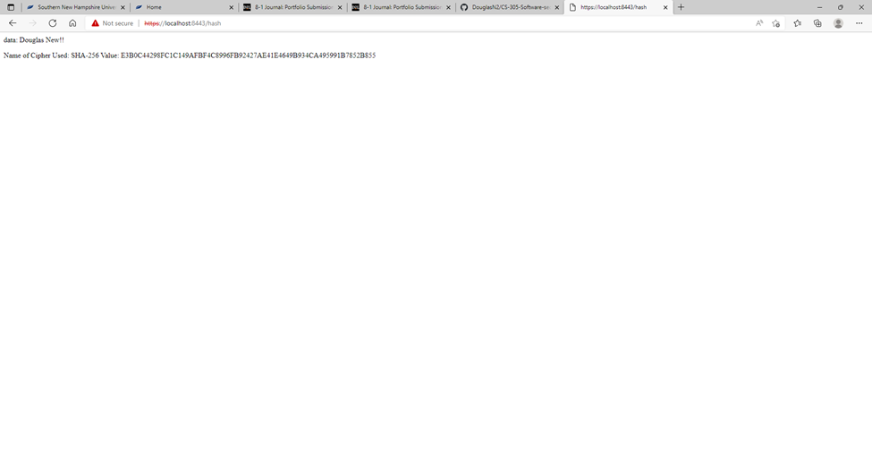

## 5. Secondary Testing

Complete a secondary static testing of the refactored code using the dependency check tool to ensure code complies with software security enhancements. You only need to focus on the code you have added as part of the refactoring. Complete the dependency check and review the output to ensure you did not introduce additional security vulnerabilities.

* Include the following below:
  + A screenshot of the refactored code executed without errors
  + A screenshot of the dependency check report

## 6. Functional Testing

Identify syntactical, logical, and security vulnerabilities for the software application by manually reviewing code.

* Complete this functional testing and include a screenshot below of the refactored code executed without errors.

## 7. Summary

Discuss how the code has been refactored and how it complies with security testing protocols. Be sure to address the following:

* Refer to the Vulnerability Assessment Process Flow Diagram and highlight the areas of security that you addressed by refactoring the code.
* Discuss your process for adding layers of security to the software application and the value that security adds to the company’s overall wellbeing.
* Point out best practices for maintaining the current security of the software application to your customer.

To reset my code, I added a secure RestController to serve as a secure controller for my hash RESTful stop programs. The ServerController class works to match the problems presented by the risk assessment diagram. In addition, I have chosen to work with the SHA-256 hashing cipher as it is very secure and uses very little chance of collision. In order to better maintain the current security of the application I can recommend a reliance test once or twice a month for the application to stay up to date with the latest risks this will help protect the company and its sensitive data. Keeping plugins within pom.xml additionally can do well to keep the latest duplicates of working plugins ensuring maximum security.